Young Researchers Wanted:
Assistive Technology, e-Accessibility, Technology & Ageing

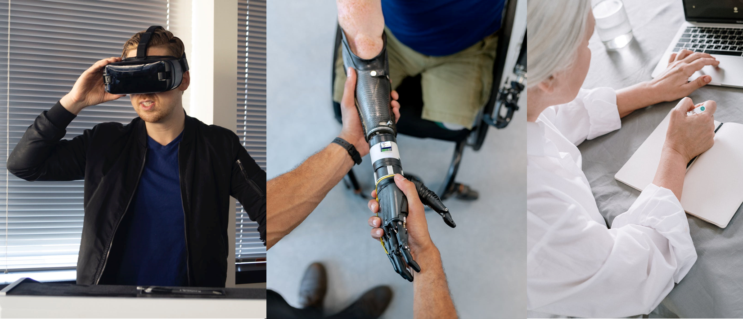

** share via your channels **

Are you…
A young researcher writing your bachelor / master / PhD thesis, or doing new research in Assistive Technology, e-Accessibility, Technology & Ageing or related topics?

Hand in your work at the
ICCHP-AAATE Young Researcher´s Consortium 2022 in Lecco, Italy

For further info, visit https://icchp-aaate.org/yrc-22

Mission
Accepted young researchers will:
- present their work during a 2-day pre-conference of the ICCHP-AAATE (July 11 and 12 , 2022)
- discuss the current state and future steps of their research with peers and experts
- learn about research in this field from experienced researchers
- participate for free in the ICCHP events (see note)
- meet new people doing research and have fun!

Please note:
- If a YRC applicant is successful and also has a paper accepted to the main ICCHP -AAATE conference, they will need to pay for a full conference registration.
- Submission of an accepted ICCHP-AAATE conference paper as a YRC submission is not permitted.

Who:
All applicants will receive detailed feedback on their application.
The panel of experienced chairs looks forward to work with young researches to help pushing their work:

Archambault, D. University Paris 8, France
Caruso, G. Politecnico di Milano, Italy
Fels, D. Ryerson University, Canada
Fitzpatrick, D. National Disability Authority, Ireland
Kobayashi, M. Tsukuba University of Technology, Japan
Morandell, M. Smart In Life, Health University of Applied Sciences Tirol, Austria
Pontelli, E. New Mexico State University, USA
Prazak-Aram, B. University of Vienna, Austria
Weber, G. Technische Universität Dresden, Germany
Zimmermann, G. Stuttgart Media University, Germany
Chen, W. University of Bergen, Norway
Ruh, D. RuhGlobal

How
Application deadline May 1st, 2022
Submit your work at: https://icchp-aaate.org/add-new-abstract

Spread it
#icchp-aaate22 #YoungResearchers #AssistiveTechnology #a11y

- The ICCHP-AAATE Young Researcher Consortium is co-organised by
- Institute Integriert Studieren, JKU Linz, Austria
- fhg health university of applied sciences tyrol, Austria
- Ryerson University, Canada

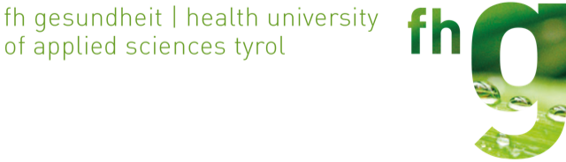

All Images from the banner are free
made a combined graphik of
https://www.pexels.com/de-de/foto/mann-hande-menschen-technologie-3912979/
https://www.pexels.com/de-de/foto/blaues-shirt-drinnen-erwachsener-fenster-1261815/
https://www.pexels.com/de-de/foto/fashion-mann-person-hande-3783249/
https://www.pexels.com/de-de/foto/frau-apple-laptop-notizbuch-4057764/

